Cultural
Heritage Administration
NEWS
Division: Natural Heritage Division
National Research Institute of Cultural Heritage
Contact person: Kang, Junghoon (042-610-7630),
Lee, Sungkyung (042-610-7631)

Natural Monument, Miho Spine Loach! Stay healthy and breed more efficiently.
- Two thousand juveniles of Miho spine loach are released in Ji Stream
in order to restore the aquatic ecosystem.
Award of Natural Heritage Experience Case Contest is Held, and
Touring Exhibition of Winners' Works -

The National Research Institute of Cultural Heritage (Kim Yeon Soo, General Director) of Cultural Heritage Administration announced in Ji Stream, Buyeo-gun, Chungnam Provinceon on October 19th that they will release approximately 2,000 Miho spine loach the natural monuments artificially hatched.

Miho spine loach are Korean endemic species that inhabit only in the basin areas of the Geum River, they are nationally protected species designated as Natural Monument and endangered wildlife with the 1st class. They were first discovered in the main stream of the Miho River near Palgyeolgyo Bridge in Cheongju in 1984, and were named Miho spine loach.

The release was implemented under a plan to sign a business agreement among the research, the Geum River Basin Environment Agency, the Korea Water Resources Corporation and the Daecheong Lake Conservation Movement Headquarters last June to cultivate awareness of protecting the public natural heritage, promote biodiversity in the aquatic system of Geum River, restore the strengths of the aquatic ecosystem, and to proliferate and preserve the Natural Monuments that are Miho spine loach.

Moreover, as a pre-release event just before the release, "Natural Heritage Experience Contest" (August 1st, 2022 - October 7th, 2022) regarding the theme of the story 'Miho spine loach, Geum River and Miho River' that are nationally protected fishes. The sum of 38 people (2 Grand Prize winners, 6 First Prize winners, and 30 Excellence Prize winners) were awarded with certificates and prizes individually. Meanwhile, 38 works that advanced to the final stage will be exhibited at Daejeon Natural Monument Center and Korea Water Resources Corporation from 20th that is upcoming.

Appendix. Photo Data.

(Appendix)
Photo Data

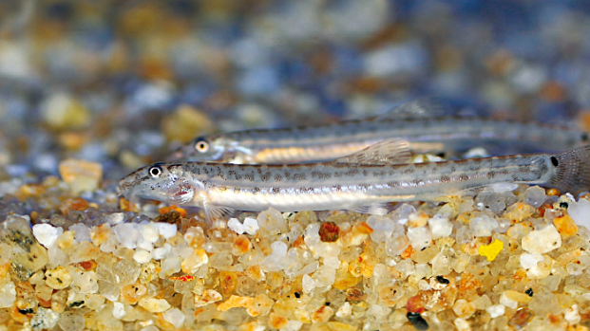
Miho Spine Loach, a Natural Monument
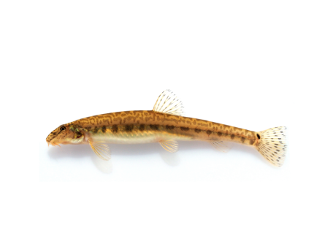
Miho Spine Loach, a Natural Monument

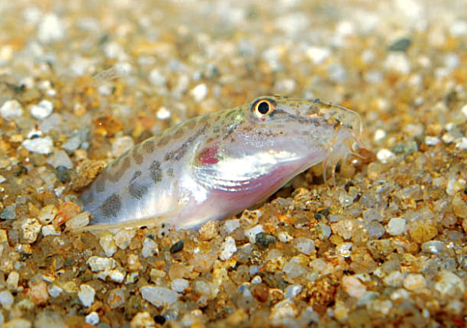
Appearance of Miho Spine Loach, a Natural Monument tha inhabit in Ji Stream
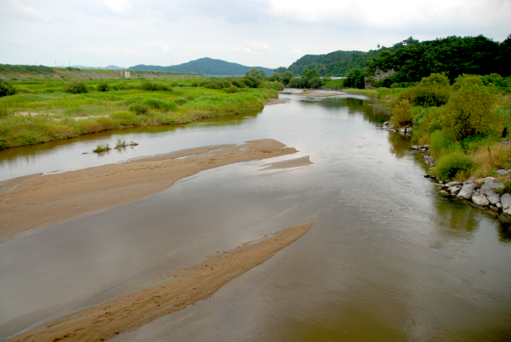
Panoramic view of Buyeo·Cheongyang-gun that Miho spine loach inhabit in

